**Task 2  
Project: Employee Payroll Management System (PostgreSQL)**Objective:  
Design and implement an employee payroll system to store, manage, and analyze salary data.  
The project will include the following tasks:  
**Database Setup:  
Create a database named payroll_database.  
Create a table employees with columns: EMPLOYEE_ID (integer), NAME (text),  
DEPARTMENT (text), EMAIL (text), PHONE_NO (numeric), JOINING_DATE (date), SALARY  
(numeric), BONUS (numeric), TAX_PERCENTAGE (numeric).**  
**Data Entry:  
Insert 10 sample employee records.  
Payroll Queries:**a) Retrieve the list of employees sorted by salary in descending order.  
b) Find employees with a total compensation (SALARY + BONUS) greater than  
$100,000.  
c) Update the bonus for employees in the ‘Sales’ department by 10%.  
d) Calculate the net salary after deducting tax for all employees.  
e) Retrieve the average, minimum, and maximum salary per department.  
  
**Advanced Queries**:  
a) Retrieve employees who joined in the last 6 months.  
b) Group employees by department and count how many employees each has.  
c) Find the department with the highest average salary.  
d) Identify employees who have the same salary as at least one other employee.

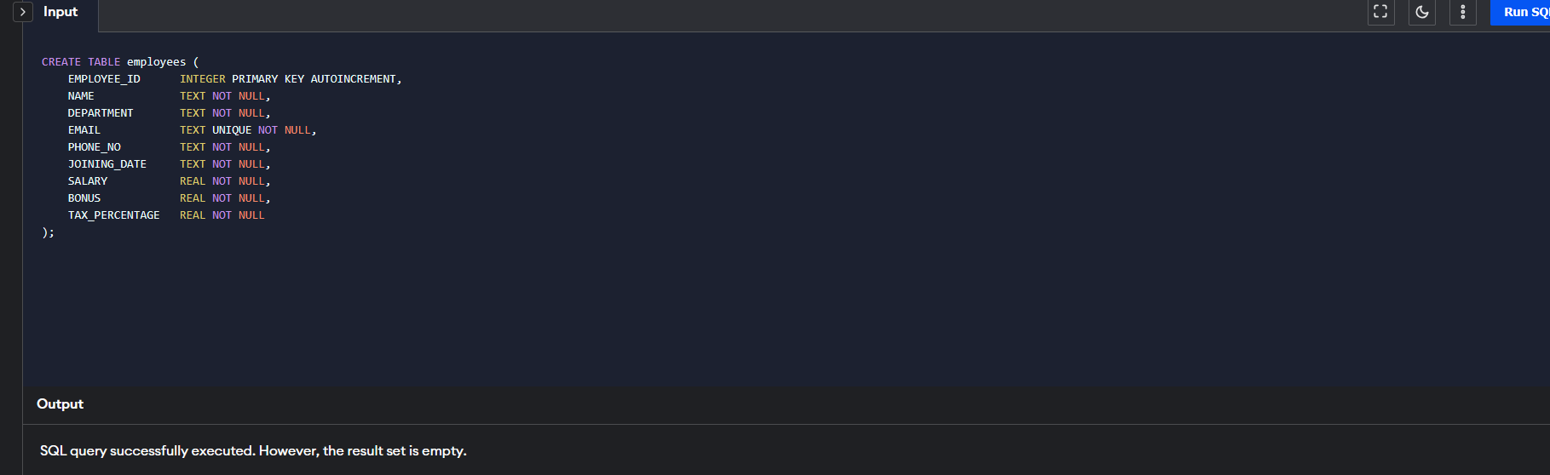

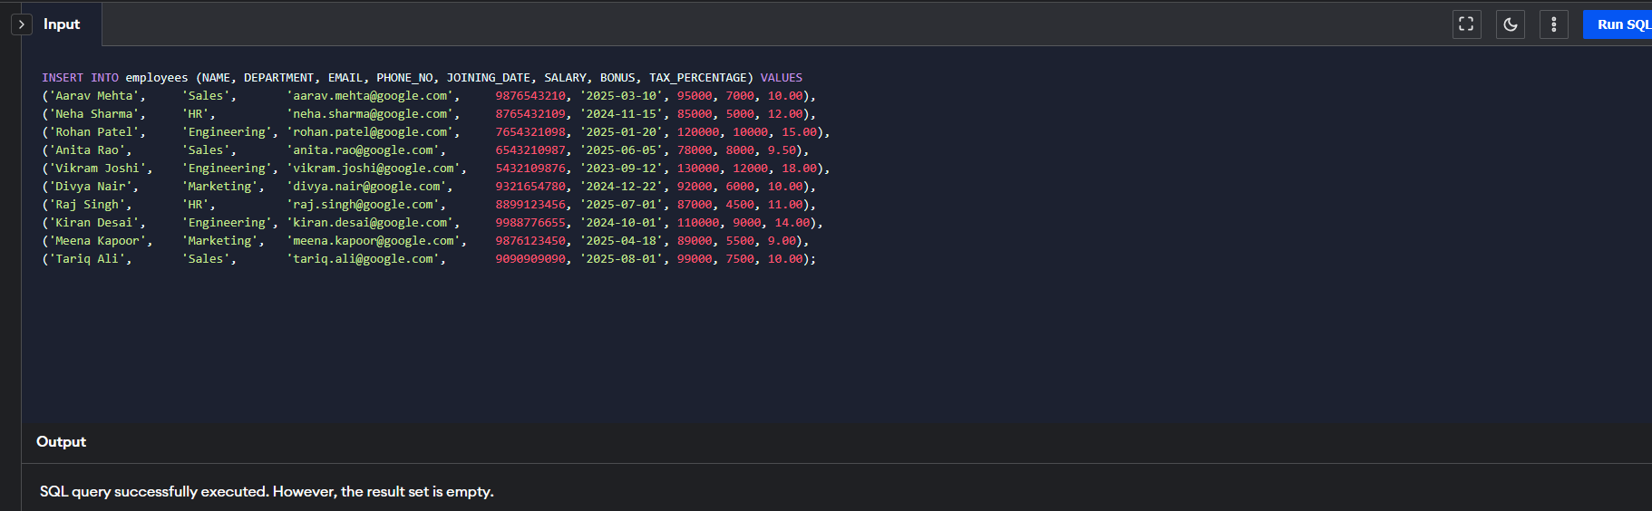

1. Retrieve the list of employees sorted by salary in descending order.

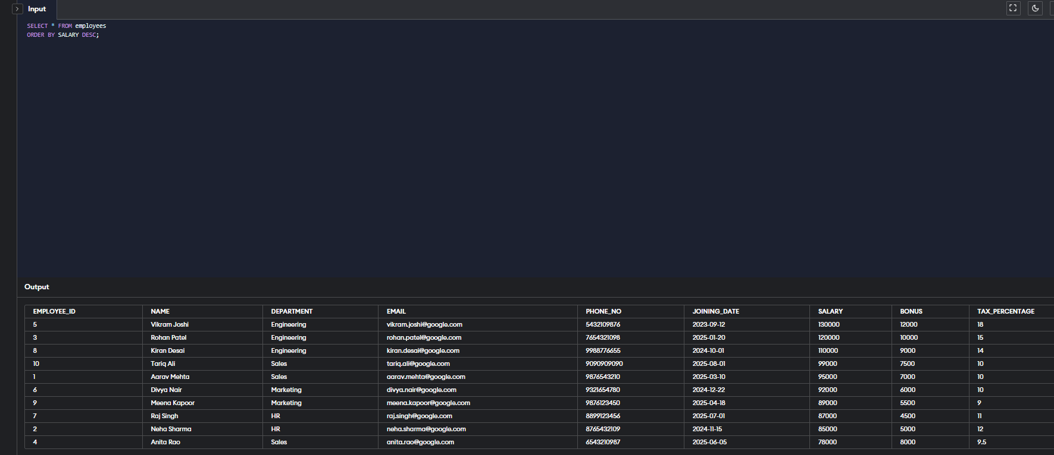

b) Find employees with a total compensation (SALARY + BONUS) greater than  
$100,000.  
  
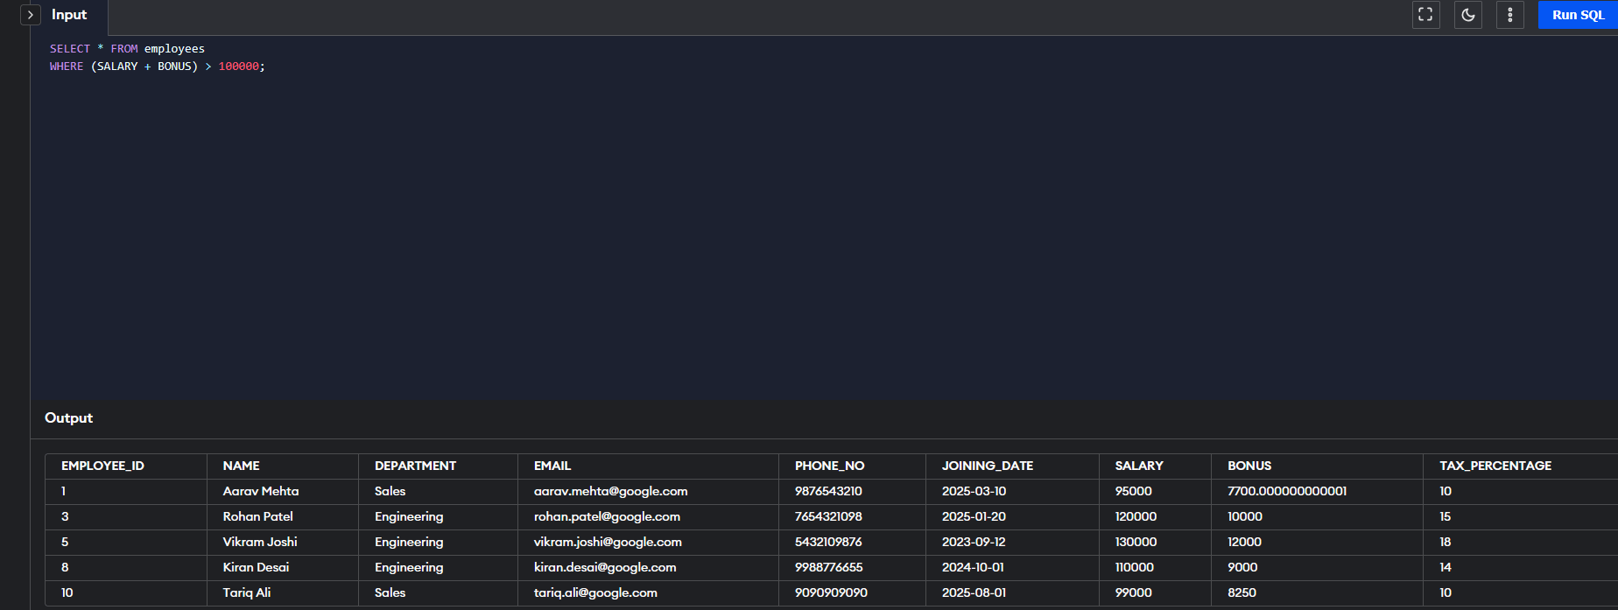

c) Update the bonus for employees in the ‘Sales’ department by 10%.  
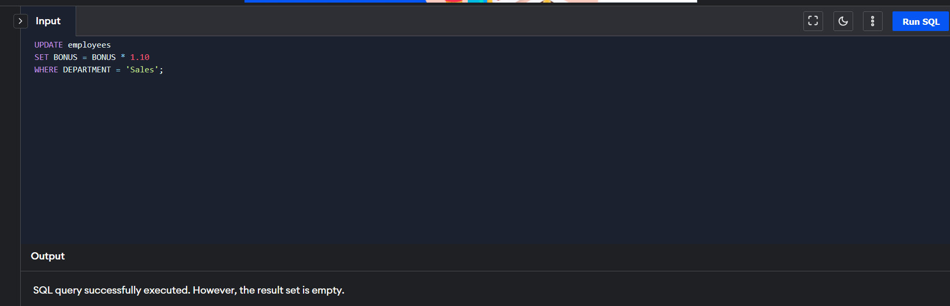

d) Calculate the net salary after deducting tax for all employees.

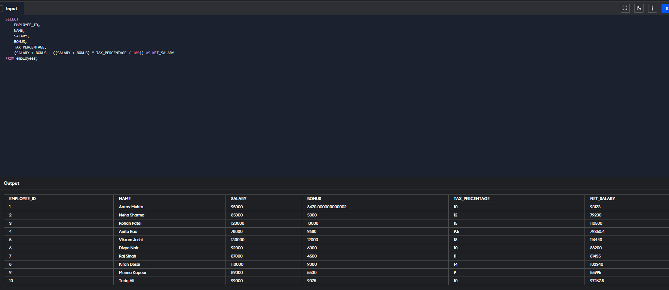

e) Retrieve the average, minimum, and maximum salary per department.

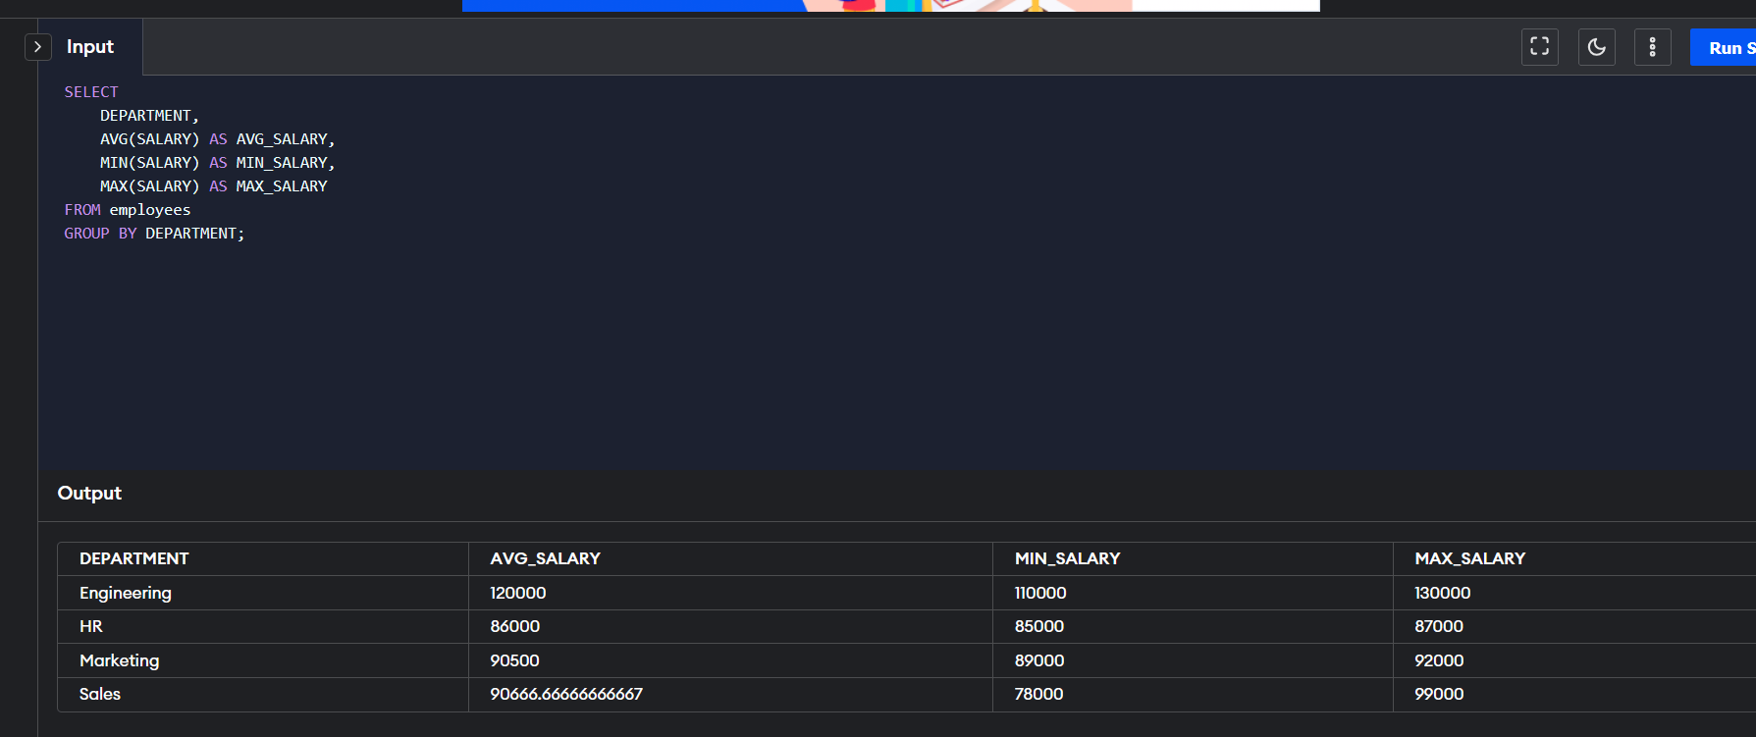

**Advanced Queries**:  
a) Retrieve employees who joined in the last 6 months.

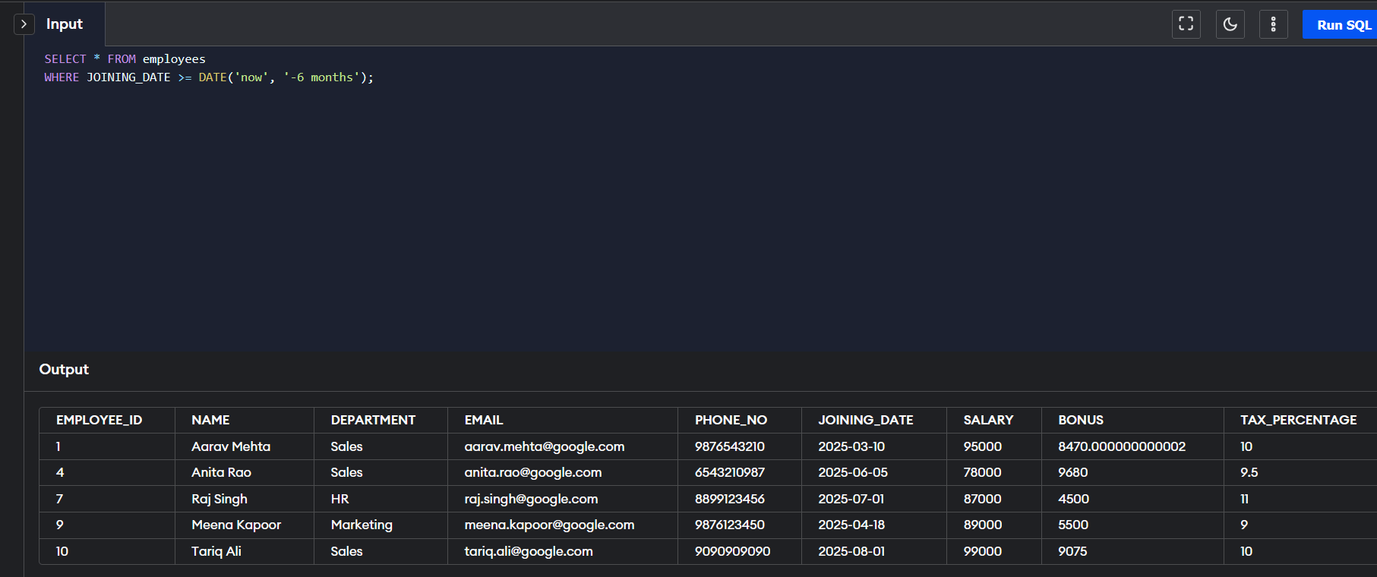

b) Group employees by department and count how many employees each has.

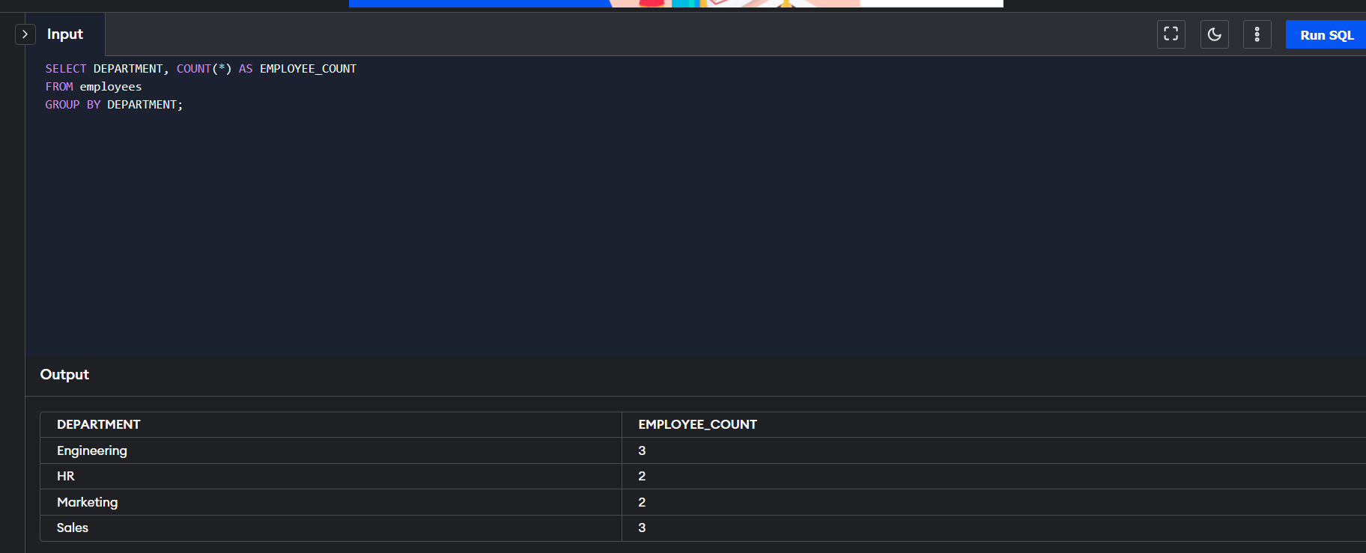

c) Find the department with the highest average salary.

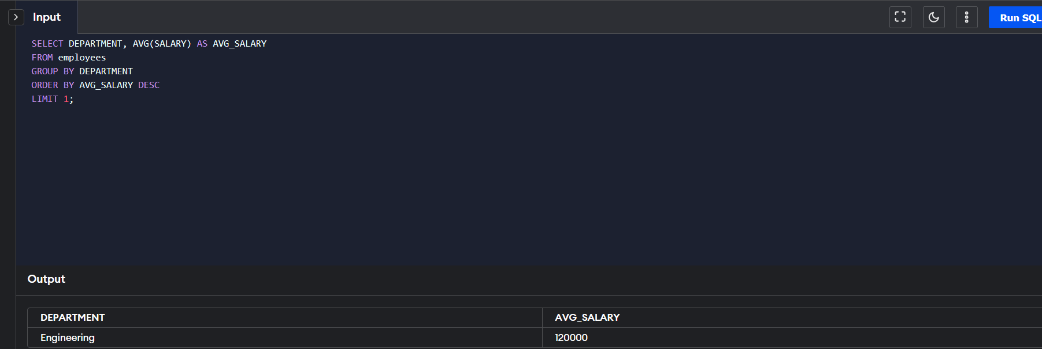

d) Identify employees who have the same salary as at least one other employee.  
